Unity lighting

***!!!IMPORTANT!!!***

***If you want to skip straight to baking and are baking an indoor scene make sure you look at the lightmap baking section, ensuring you look at the setting up objects part***

Contents

Light types 2

Cookies 2

Spot light 2

Point light 3

Directional light 3

Area light 3

Emissive Materials 3

Other Lighting components 4

Light Probe Group 4

Light probes and baked lightmap VS Realtime Lighting 6

Baking Lightmaps 7

Setting up lights for lightmap baking 7

Setting up objects for lightmap baking 7

Baking 8

Post processing effects 9

Enabling post processing 10

Bloom 11

Colour adjustments 11

Vignette 12

Global illumination 12

# Light types

## A screenshot of a video game AI-generated content may be incorrect.Cookies

While not a lighting type, they are a key thing we want to be aware of with lights, they allow us to put a mask on the projected light, typically this is used for caustics (like shown in the image) but can be used for several other things.

They can be added to any light type to create various effects. A water caustics effect can be found in the lighting demo folder of the scene folder

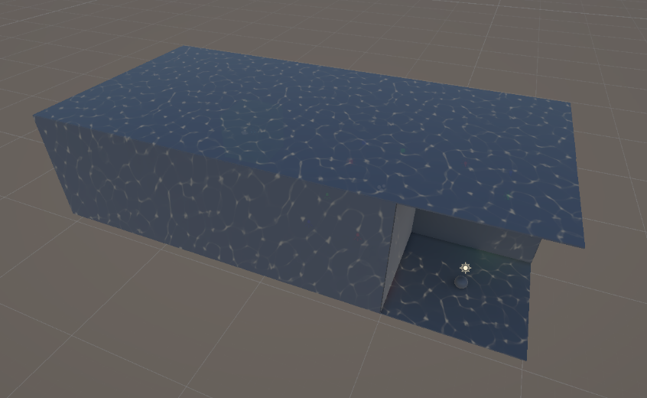

## Spot light

Standard game engine spot light. Casts a cone of light, default direction is straight down. Cone range and angle can be adjusted.

## Point light

Standard game engine point light. Casts a sphere of light around a point in space. Size of the sphere of light being cast can be adjusted.

## Directional light

Standard game engine directional light casts an infinite, perpendicular light meant to emulate the sun’s lighting.

## Area light

Like Unreal’ s Area rectangle shape, defined by a rectangle and range, the area light casts light out across the surface of its rectangle in all directions (except behind the rectangle). ***This is a bake only type of lighting***

## Emissive Materials

Emissive Materials allow us to add fake lighting to the scene on non-light objects.

To make a material emissive, create a URP lit material and tick the emissive checkbox. How we control the actual intensity of the emissive can be found under the colour itself. There is an intensity slider neat the bottom as can be seen below.

# Other Lighting components

## Light Probe Group

Baked lights such as area lights do not allow for inate interaction with dynamic objects, this may be a problem. However there is a way to somewhat circumvent this with the use of light probe groups.

Light probe groups allow us to use the data from the baked lightmaps to estimate the lighting contribution of baked lights on a dynamic object without the need for “mixed” or “dynamic” Lights.

Once in the scene and selected they can simply be editted using the edit light probe group option on the side bar of the viewport, this will then bring up the edit light probes options

Before editing the probes its important to note that the lightmap sampling (where it calculates where to take the lightmap data from) is done on the yellow vertexes of the probe group, these are the probes after all. **The more probes in the probe group, the more accurate the lighting sampling will be on dynamic objects, however, more probes also means more performance usage.**

Your options for editing the probe group are simple, they do exactly what they say on the tin, **The quickest way to fill a scene is to drag select some nodes, dupilicate them and move them**. Any probes added to a probe group will automatically connect to the probe group

Here is what the area light room looks like filled with lightmap probes. Note that I have specifically placed probes on areas with overlapping light. When placing Probes the best way to think about it is like placing vertexes on a 3d model, large areas with little variance only want a few, but areas with lots of detail (overlapping different coloured lights for example) want a lot more.

**You may also want to raise the bottom nodes slightly above the floor, if a node is inside of a mesh its light sampling will likely be incorrect.**

So now if I bring back the dynamic sphere, we can see that it is now able to utilise the baked area lighting, and because of the careful node placement, we now have correct lighting on the overlapping lights

## Light probes and baked lightmap VS Realtime Lighting

When deciding between using Light probes or Realtime (dynamic) lighting, the key thing to ask yourself is, do the lights move. If the lights, or light moves, leave it Realtime. If not, it’s likely going to be much more performant to bake and use light probes. Also remember, light probes are only necessary for areas in the scene where we expect dynamic objects to be.

# Baking Lightmaps

## Setting up lights for lightmap baking

To set a light up ready to be baked, its quite simple, with a light selected in the scene, go to the inspector, look for the Light component, and set the mode to “Baked” or “Dynamic”. **Note that Area lights are “Baked” only.**

Different scenarios will require different modes, and having a light that interacts with dynamic objects may not always require the “Dynamic” lighting mode, see **Light Probe Groups** in the **Other Lighting Components** section for more information.

## Setting up objects for lightmap baking

To set objects up for lightmap baking is also quite simple, with an object or objects selected in the scene, go to the inspector, look for the “**static**” checkbox in the upper right corner, and make sure it is enabled. Additional lighting settings can be found under the “**Mesh Renderer**” component. Any objects that aren’t set to static will not be included in the lightmap.

Another thing that we can use for objects is baking shadows, to bake the shadows of an object into the lightmap we simply select “Static Shadow Caster” in Lighting settings of the mesh renderer.

***!!!IMPORTANT!!!***

If we end up making any kind of indoor scene with roofing, please avoid using planes. It will cause severe issues with lightmaps:

Instead please use squashed down cubes for any large flat surfaces where you would typically use a plane.

If you bake an object and the lightmaps are messed up on a specific object it is likely due to incorrect lighting UVs. Check the model in your modelling software for any UVs that arent correctly unwrapped, often when this occurs it is due to a second set of UVs on a model that are still in their default positions.   
  
if you have other issues with your lightmap baking please let me (callum) know or post something in the discord.

## Baking

Once your scene is setup, we can start baking, firstly we’ll need to open two windows, only one is required but the other is useful for debugging and tracking lights in a scene. We want to open the lighting and light explorer windows

With these open you can drag the little tab at the top to dock it somewhere in the editor, I like to dock it next to the inspector like so.

There are lots of settings here but the main thing we want for now is the scene tab. Here you will see at the top, a Lighting Settings Asset field, in here you want to set that to the “**GameLightingSettings**” lighting asset, this is one I have set up and will provide us nice looking but also relatively optimal lightmaps. With the lighting settings asset set up, all that’s left to do is click the big “Generate Lighting” button at the bottom of the window and wait for it to bake.

Another thing to note is the skybox, this affects the lightmap baking

# Post processing effects

Post processing effects are a nice easy way for us to control the atmosphere of the game all from a single object. Below we can see a scene with several emissive objects, The left side is the standard view, no post processing, and the right we have 3 post processing effects (Bloom, Colour adjustment and Vignette)

There are far too many post processing effects to cover them all but I’ll go over some and how to set them up.

## Enabling post processing

.

Global volumes are for effects that cover the entire scene, the other volumes are for specific smaller sections of the scene.

One thing to keep in mind before adding post processing to a scene you make would be “is my scene an entire level, or a section of a level?”, if it is an entire level on its own. Great, post process all you want, try to keep it consistent with the style and look of the rest of the game.

If, however, your scene may simply be a subsection of a larger level, don’t go just adding post processing effects without discussing it with other people. This may cause some severe issues with overlapping effects.

Onto my next point, these volumes can overlap, you can have a global volume with smaller local volumes inside, here is how they interact.  
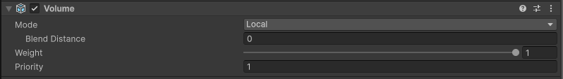

Volumes have a priority, the bigger the number, the bigger the priority. When a camera enters a region with two overlapping post processing volumes, it will pick the one with the highest priority and ignore the other volumes entirely. If two volumes are on the same priority, this is where we want to use weight. It is highly unlikely that we will ever want overlapping volumes, we should avoid it where possible. However, if we do use it, and they need to both be used, we can blend the two volume’s effects using the weights, it tells us how much of each weight should be used when they overlap.

## Bloom

Bloom affects lighting effects above the threshold, scattering the lighting. On the left is emissive objects without bloom and on the right is emissive objects with bloom.

## Colour adjustments

Colour adjustments allow us to control the overall colour of the scene, we on the left is without colour adjustments, on the right is the same scene with some colour adjustments, mostly just a Hue shift.

## Vignette

Vignette is another key element for atmospheric camera effects, it adds a coloured edge to the edge of the camera, this can be used to make the scene feel darker, or to add the red edges around the screen to indicate low health.

# Global illumination

This section wont go in depth about GI, I’ll just cover the basics of setting it up. Going back to the lighting settings asset from the lightmap baking, we already have most of the GI set up in there. Currently it is set to both baked and Realtime, so make sure that the “GameLightingSettings” is set in your scene lighting settings.

Setting up an object to interact with global illumination is simple, we can simply select the dropdown next to the static object toggle and make sure “contribute GI” is ticked, setting an object to static will do this automatically.

To control how the object affects the baked lightmaps, the options for that can be found under the lighting section of the object’s mesh renderer.

